2016

Jonathan Ratnavel, Michael Drent, Alex Abdalla, Thijs van den Boogaart, Joyce Lam, Bryan Fernand

SEF01

1-1-2016

User Manual Appkiller



Thank you for downloading the Application killer App! This application will provide you with a faster and a more sustainable desktop and/or laptop.

This manual contains the instruction of how to use the Application Killer app. After reading this manual you will be able to use the basic configuration already provided by this application, kill and unkill certain applications and make your own kill configurations.

Table of content

1. How to use the basic configuration 2

2. Kill applications 3

3. Unkill applications 4

4. Make your own configuration 6

# How to use the basic configuration

When you click on the application, the application will direct you to the homepage.

1. When you are at the homepage, press the ‘Kill’ button to activate the basic configuration. The basic configuration will kill all the unneccesairy, killable applications on your desktop/laptop.

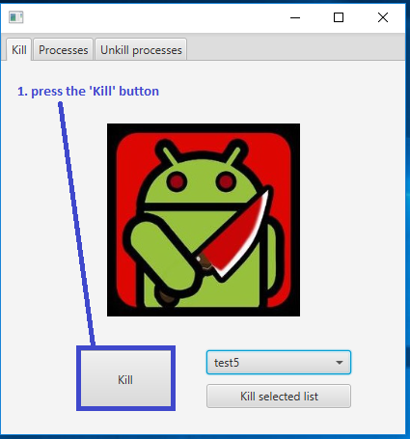

Note: Only use the basic configuration when you just started up the computer, or when you want all killable applications to be shut down. The basic configuration will kill all killable applications, such as Internet Explorer, DivX media player and Google Chrome.

# Kill applications

When you click on the application, the application will direct you tot the homepage.

1. When you are at the homepage, click on ‘Processes’.
2. When you are in the processtab, select the process you want to kill.
3. Press ‘Kill’.
4. When you have started up a new process on the computer while you were already in the process, press ‘Refresh’. This will refresh the process page and the recently started process will show up in the processlist.

Note: you can only select one proces. If you want to kill multiple processen you have to kill them one by one.

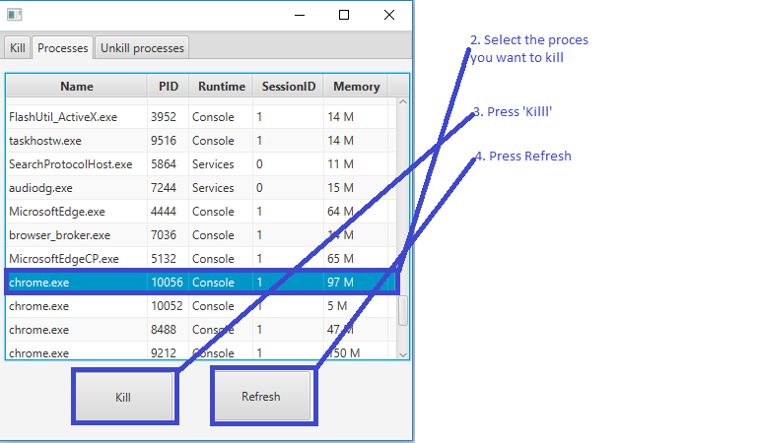

# Unkill applications

When you click on the application, the application will direct you tot the homepage.

1. When you are at the homepage, click on ‘Unkill processes’.

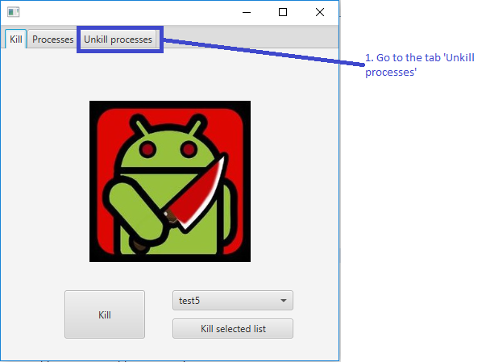

1. Select the application you want to unkill.
2. Press ‘Undo’.
3. When a application is already unkilled, but it still stands in the unkill list, select the application.
4. Press ‘Delete Selected’.

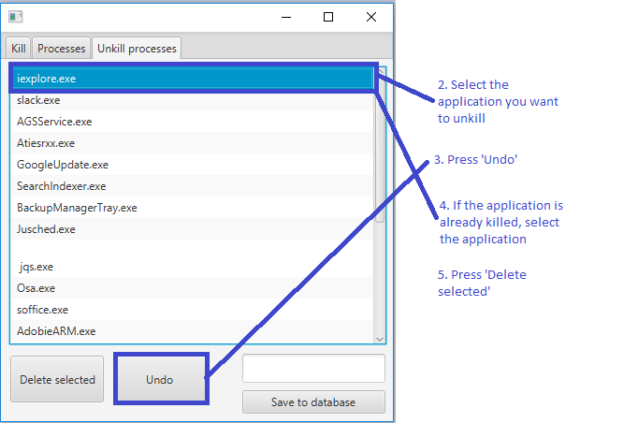

When you click on the application, the application will direct you tot the homepage.

# Make your own configuration

When you click on the application, the application will direct you tot he homepage.

1. Go to the tab ‘Unkill processes’.



1. Remove all processes you dont want to be saved in your list. You can do this by selecting the processen and pressing ‘Delete selected’.
2. Give your list a name.
3. Click on ‘Save to database’ to save the list in the database provided by the application.
4. Go back tot the tab ‘Kill’.
5. Select your list with the drop down menu.

